Project Report

POLITICAL JUGGERNAUTS: A QUANTITATIVE ANALYSIS OF CANDIDATES IN THE 2019 LOK SABHA ELECTIONS

1. INTRODUCTION

This project deals with 2019 lok sabha elections.

Major parties participated in the election.

BJP won with maximum no of votes.

* 1. OVERVIEW

There were 8039 candidates contesting for 542 Parliamentary constituency seats.

On average, 14.8 candidates are contesting per constituency across the country.

Among all the states, Telangana had the highest average number of candidates contesting.

* 1. PURPOSE

The purpose of this report is to analysis various candidates contested in the election.

The goal is to share the information to every nook and corner of the country.

2.PROBLEM DEFINITION THINKING

EMPATHY MAP

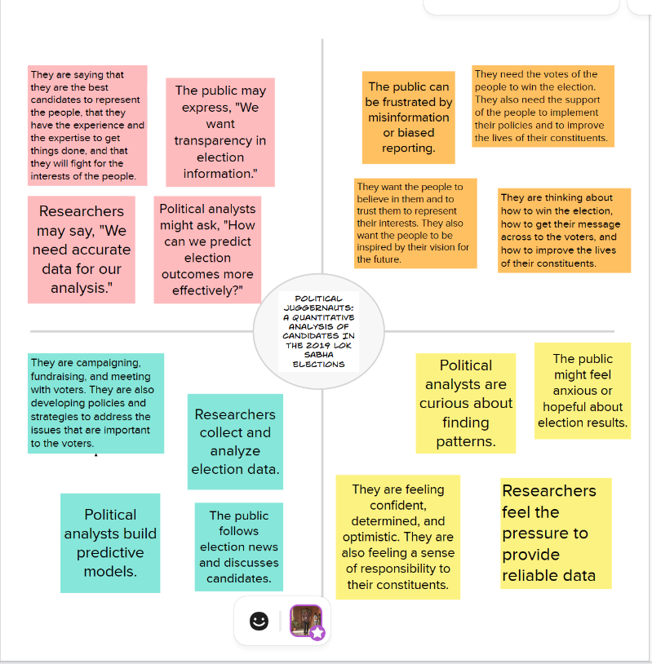

BRAINSTORMING

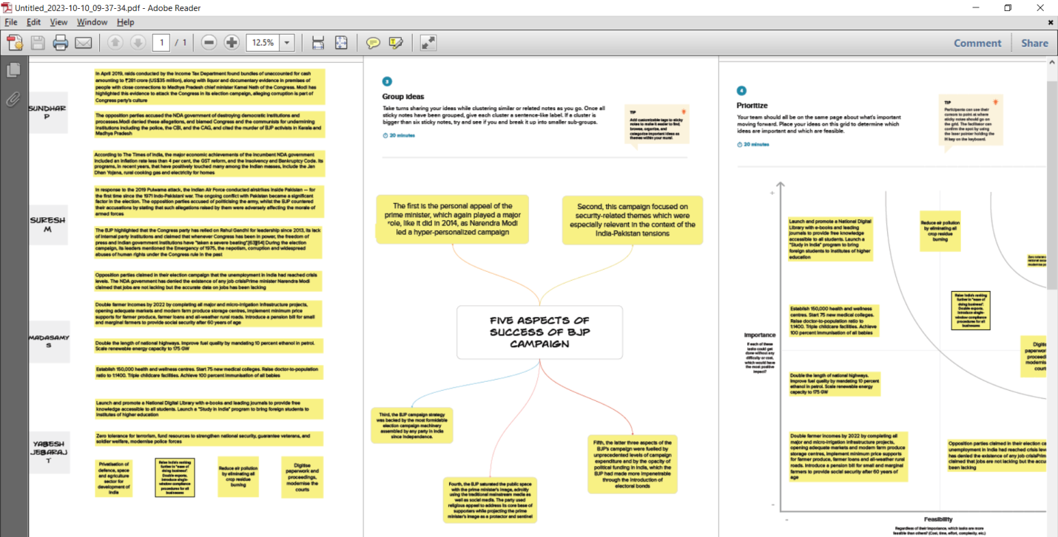

3.RESULT

DASHBOARD AND STORY

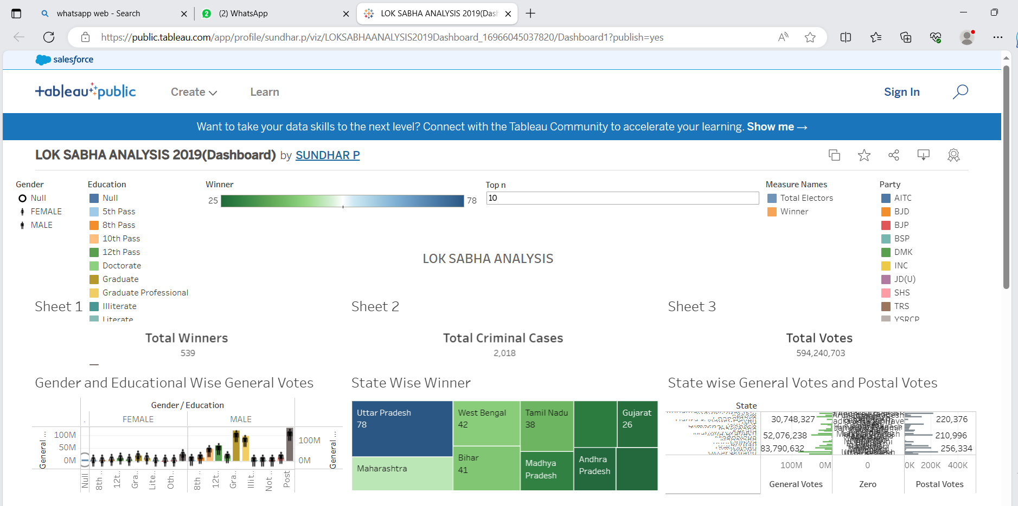

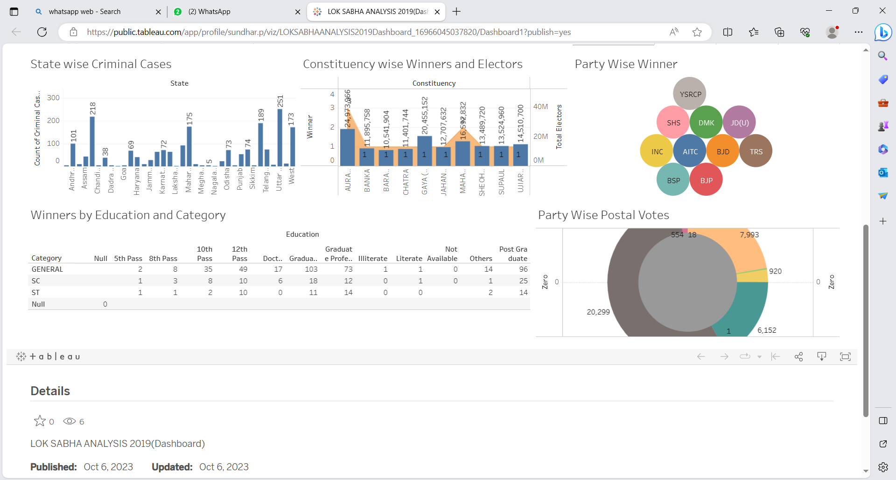

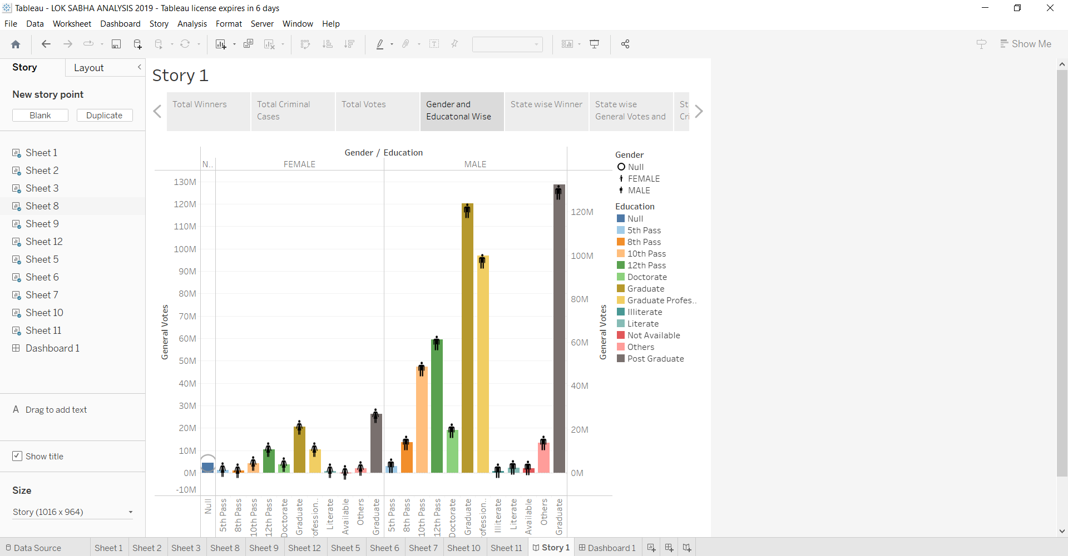

4.APPLICATIONS

This project paves way for us to understand various information of 2019 election

Sequentially more younger candidates develop interest in participating in elections.

5.CONCLUSION

Here maximum information is given for the different departments to go through.

We have included charts for better and easy understanding.

6.FUTURE SCOPE

Many students will engage in learning politics.

Candidates participating will be of higher caliber.